SATISH CHANDRA MEMORIAL SCHOOL
PRACTICE TEST – HOTS QUESTIONS
SUBJECT – SCIENCE CLASS-VI

- Answer the following questions –

1. a. If you sketch the Big Dipper at 8:00 PM and again at 11:00 PM, what change will you notice in its position relative to the horizon? (1 Mark)
b. If you performed the same observation on the Pole Star, what change would you see? Provide a reason for this. (1 Mark)

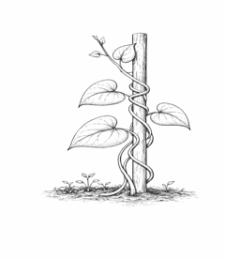
2. A student observes that a climber plant winds its stem around a nearby wooden stick.
Is this movement a response to a stimulus? Identify the stimulus and name the specific type of movement. (2 Marks)

3. A two-wheeler has been parked in the sun for hours, and the black seat has become painfully hot. You decide to pour a little water over the seat to cool it down before sitting.
a. Write the change in the state of water that occurs when water touches the hot seat. (1 Mark)
b. Why does the seat cool down almost instantly after the water disappears? (1 Mark)

4. Deepa is sitting on a moving bus and notices that her friend Padma is sitting perfectly still in the seat next to her. However, a man standing on the sidewalk sees both Deepa and Padma moving past him.
a. With respect to the bus as a reference point, is Padma at rest or in motion?. (1 Mark)
b. Why does the man on the sidewalk see Padma as being in motion?. (1 Mark)

5. You are standing exactly on the Earth's equator with a freely suspended bar magnet.
a. Will the magnet point in a specific direction? If so, which one? (1 Mark)
b. Why does this happen even though there are no other magnets nearby? (1 Mark)

6. Early in the morning, a bus driver looks through the windshield (Material X). As the bus fills with passengers, the windows begin to "fog up" with tiny water droplets (Material Y). The driver then pulls down a thick plastic sunshade (Material Z) to block the rising sun.

a. The windshield started as X, but the fog turned it into Y. What happened to the light's path to make the view go from clear to blurry? (1 Mark)
b. If the driver wipes a small circle in the fog with his hand, has he changed the material back to X? (1 Mark)

7.You have a mixture of P (large pebbles), Q (cooking oil), and R (water).
- P is at the bottom.
- Q is in the middle.
- R is floating on top.
You have a Sieve and an Empty Beaker. Write the name of the processes sequence wise to separate P, Q and R.

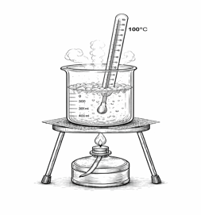
8. A student is heating a pot of water on a stove. He places a laboratory thermometer in the water. He notices that the temperature rises steadily until it reaches 100ºC. Even though the stove is still turned on and providing heat, the thermometer reading stops increasing and stays at exactly 100 º C while the water boils vigorously.
Question- If heat is still being added to the water, why does the temperature not rise above 100ºC. Justify your answer. (2 Marks)

